Project Design Phase
Problem – Solution Fit Template

Date | 26 September 2026
Team ID | SWTID-2026-5465
Project Name | AI Study Buddy
Maximum Marks | 2 Marks

Problem–Solution Fit
Problem–Solution Fit means identifying a real problem faced by your target customers and developing a solution that effectively addresses that problem. It helps entrepreneurs, marketers, and organizations understand customer needs, identify behavioural patterns, and determine which solutions are most useful and why.
Purpose:
- Address complex problems by creating solutions that match the actual needs of customers.
- Improve the chances of faster success and solution adoption by using existing customer behaviours and communication channels.
- Strengthen communication and marketing strategies through suitable messages and customer triggers.
- Increase customer engagement by identifying frequent, urgent, or costly problems and providing effective solutions.
- Understand the current situation and customer expectations to develop better solutions for the target group.

References:
- https://www.ideahackers.network/problem-solution-fit-canvas/
- https://medium.com/@epicantus/problem-solution-fit-canvas-aa3dd59cb4fe

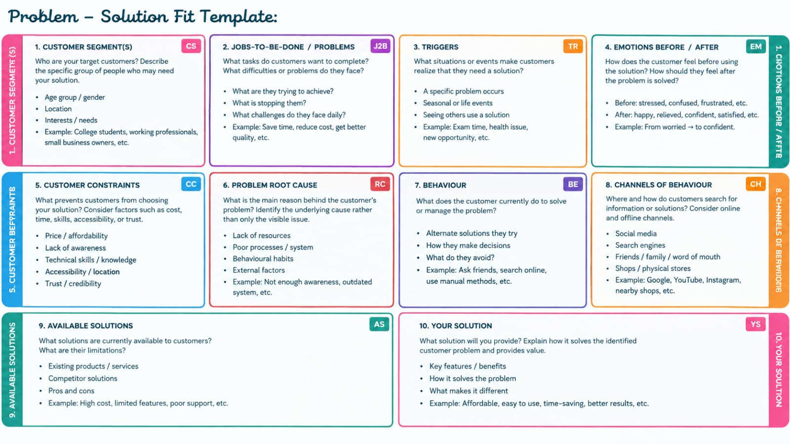
Template:

